

SURREY ARCHAEOLOGICAL SOCIETY
A Company Limited by Guarantee. A Registered Charity No. 272098

Registered Office: CASTLE ARCH, GUILDFORD GU1 3SX Registered in England No. 1160052
Telephone/Fax: 01483 532454 Email: info@surreyarchaeology.org.uk

Medieval Studies Forum
“More Medieval Towns in Surrey”
The Banstead Methodist Church Hall, The Drive, Banstead
Saturday 14th November 2009
Programme

10.30 am Tea and coffee available

10.55 am Welcome & Introduction

11.00 am ‘Kingston – A Town on the Thames’ : Dr David Robinson, formerly County Archivist of Surrey

11.45 am ‘Croydon: Town on the Edge’ : Dr Oliver Harris, Research Fellow, University College London

12.30 pm Lunch - bring your own sandwiches – tea and coffee available

1.15 pm AGM

1.30 pm ‘The Colonization of Medieval Lingfield’ : Mrs Janet Bateson, Chairman, Hayward Memorial Local History Centre

2.15 pm ‘Medieval Haslemere: a bishop’s town foundation’ : Mr Peter Balmer, Surrey Archaeological Society

3.00 pm Tea

3.15 pm Open Forum Discussion: Introduced by Peter Balmer

4.00 pm Close

The charge for this meeting of the Forum is £6 payable on the day: no tickets will be issued. It would be very helpful, particularly for catering arrangements, if you could let us know if you will be attending this meeting. For directions, parking and other details see overleaf.

Medieval Studies Forum
14th November 2009 – The Methodist Church Hall, The Drive, Banstead, SM7 1DA
I/We will be attending the above meeting. Number attending ……….
Name ………………………………………………………………………………………………………………..
Tel No. …………………………… Email/Address …………………………………………………………..
......................................................................................
Replies to: Peter Balmer, 9 Herondale, Haslemere, Surrey, GU27, Tel 01428 658213
Or e-mail: surreymedieval@googlemail.com

DIRECTIONS

The Drive is just off the Brighton Road (A217).
If coming by car from the north, after passing THE DRIVE, turn right into TATTENHAM WAY, take the next right into PIQUETS WAY and then right into THE DRIVE.
If coming from the south, turn left into THE DRIVE.

Banstead train station situated in Banstead Road, off Fir Tree Road is a little under a mile away.

Bus Service 420 operates an hourly on a Saturday between Reigate and Sutton and passes fairly close to The Drive. It travels along Tattenham Way, up Brighton Road and into Garratts Lane and back again.

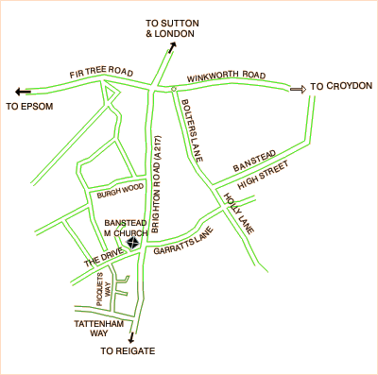

PARKING
Parking is available in the church car park at the front of the building.

LUNCH
As there are limited opportunities to purchase lunch in the vicinity (Banstead High Street is over half a mile away) it is suggested that you bring a packed lunch to eat in the Hall. Tea and coffee will be available in the hall during the lunch break.

