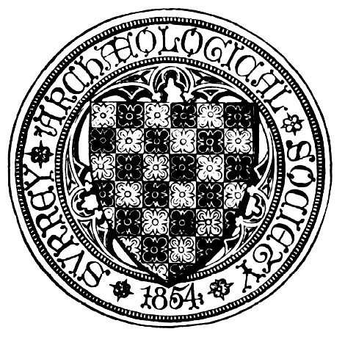

SURREY ARCHAEOLOGICAL SOCIETY
A Company Limited by Guarantee. A Registered Charity No. 272098

Registered Office: CASTLE ARCH, GUILDFORD GU1 3SX Registered in England No. 1160052
Telephone/Fax: 01483 532454 Email: info@surreyarchaeology.org.uk

Medieval Studies Forum
“Medieval Roads, Bridges and Causeways”
Surrey History Centre, 130 Goldsworth Road, Woking
Saturday 12th June 2010
Programme

10.30 am Tea and coffee available

10.55 am Welcome & Introduction

11.00 am ‘A General Introduction to the topic, illustrated by examples from the Upper Thames’: Professor John Blair, The Queen’s College, Oxford

11.50 am ‘The Pyrford and Old Woking Causeways’: Richard Savage, Surrey Archaeological Society

12.20 pm ‘Roads and Tracks in South West Surrey’: Hugh Turrall-Clarke, Surrey Archaeological Society

12.45 pm Lunch – tea and coffee available. See note on page 2

1.45 pm ‘The King’s Highway through Thorpe’: Phil Jones, SCAU

2.15 pm ‘Guildford Bridge’: Dr Mary Alexander, Surrey Archaeological Society

2.45 pm Tea

3.10 pm ‘What happened to that road? - some lost roads in Surrey’: John Wettern, Surrey Archaeological Society

3.25 pm Open session for attendees to report on relevant research

4.15 pm Close

The charge for this meeting of the Forum is £6 payable on the day: no tickets will be issued. It would be very helpful, particularly for catering arrangements, if you could let us know if you will be attending this meeting. For directions, parking and other details see overleaf.
__________________________________________________________________________________________________________________________________
Medieval Studies Forum
12th June 2010 –Surrey History Centre, 130 Goldsworth Road, Woking, GU21 6ND
I/We will be attending the above meeting. Number attending ……….
Name ………………………………………………………………………………………………………………..
Tel No. …………………………… Email/Address …………………………………………………………..
......................................................................................
Replies to: Peter Balmer, 9 Herondale, Haslemere, Surrey, GU27 1RQ, Tel 01428 658213
Or e-mail: surreymedieval@googlemail.com

Location of Surrey History Centre

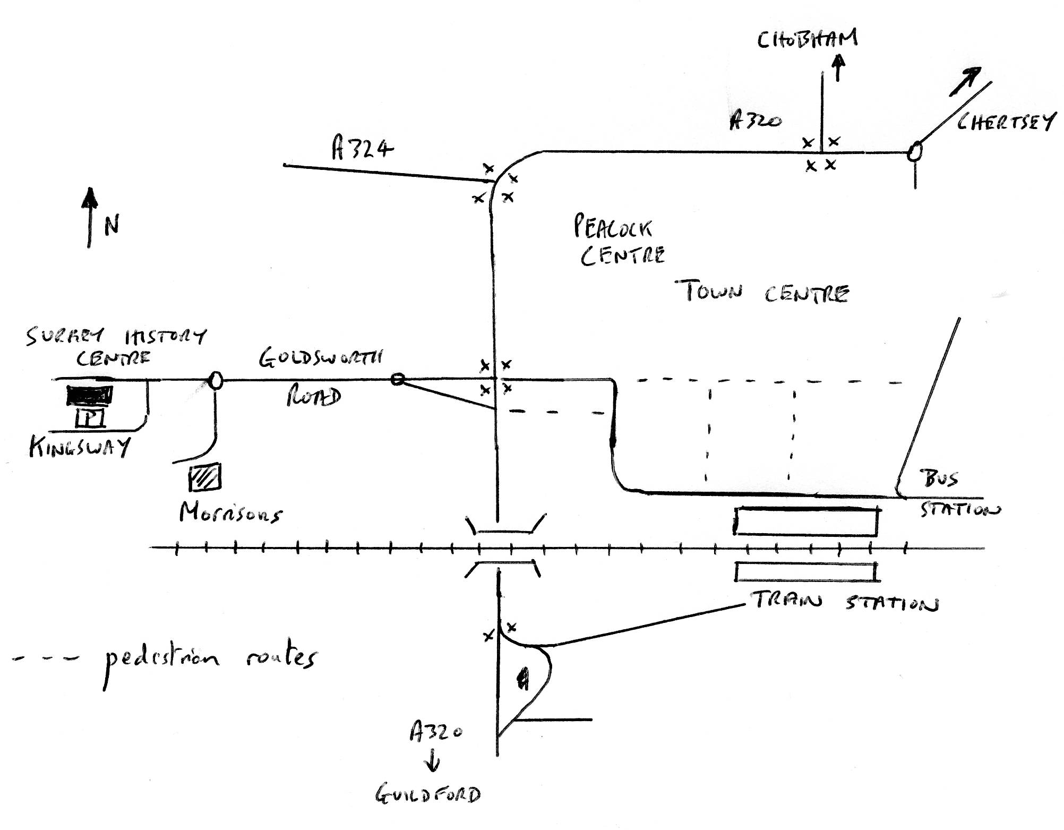

Surrey History Centre is located at 130 Goldsworth Road in Woking. It is approximately 2/3 of a mile from the Train and Bus Stations via the pedestrian route. Exit the train Station on the northern or town side i.e. from Platform 1.

PARKING

Parking is available free of charge at the Surrey History Centre. Access to the car park is from Kingsway at the rear of the building.

LUNCH

You are welcome to bring a packed lunch, tea and coffee will be available. The Surrey History Centre is about 15 minutes walk from Woking Town centre with its coffee shops, cafes and bakeries. There is a pub quite close by and Morrison’s Supermarket, which is about 5 minutes walk away, has a café and also sells sandwiches and salads etc.

