

SURREY ARCHAEOLOGICAL SOCIETY
A Company Limited by Guarantee. A Registered Charity No. 272098

Registered Office: CASTLE ARCH, GUILDFORD GU1 3SX Registered in England No. 1160052
Telephone/Fax: 01483 532454 Email: info@surreyarchaeology.org.uk

Medieval Studies Forum & Villages Study Group
“Test Pitting and the Development of Villages”
Surrey History Centre, 130 Goldsworth Road, Woking, GU21 6ND
Saturday 12th March 2011
Programme

10.30 am Registration: Tea and coffee available

10.55 am Welcome & Introduction by the Day Chairman, Dr Joe Flatman, County Archaeologist for Surrey

11.00 am ‘The CORS Programme and HEFA in East Anglia’: Dr Carenza Lewis, University of Cambridge

11.45 am ‘Early-modern documentary sources as indicators of village development’: Dr Catherine Ferguson, University of Sussex

12.15pm ‘Panel Q & A’: Carenza Lewis, Catherine Ferguson, Joe Flatman

12.45 pm Lunch – (tea and coffee available) see note on page 2

1.30 pm ‘Results of Test-pitting in Old Woking ’: Richard Savage, SyAS

2.10 pm ‘Next Steps - Future focuses on Surrey Villages’: Chris Hayward, SyAS

2.30 pm ‘Possibilities for wider test-pitting in Surrey and Youth Involvement’: Abby Guinness, Community Archaeologist (SCC) & Paul Bowen, County Youth Development Officer (SCC)

3.00 pm ‘Open Discussion Session’: Moderated by Joe Flatman

3.30 pm Close: please note that the Surrey History Centre closes promptly at 4 pm

The charge for this meeting is £6. As the meeting is likely to be fully subscribed tickets will be issued in advance and can be obtained from Castle Arch. Please send your application together with a stamped SAE and a cheque made payable to Surrey Archaeological Society to Emma Coburn, Surrey Archaeological Society, Castle Arch, Guildford, GU1 3SX. For directions, parking and other details see overleaf.
__________________________________________________________________________________________________________________________________
Medieval Studies Forum
12th March 2011 –Surrey History Centre, 130 Goldsworth Road, Woking, GU21 6ND
I/We will be attending the above meeting. Number of tickets required ……….

Name…………………………………………………………………………………………………………...
Address………………………………………………………….......................................................................
.............................................................................................................................................................................. Tel No. ……………………………

Location of Surrey History Centre

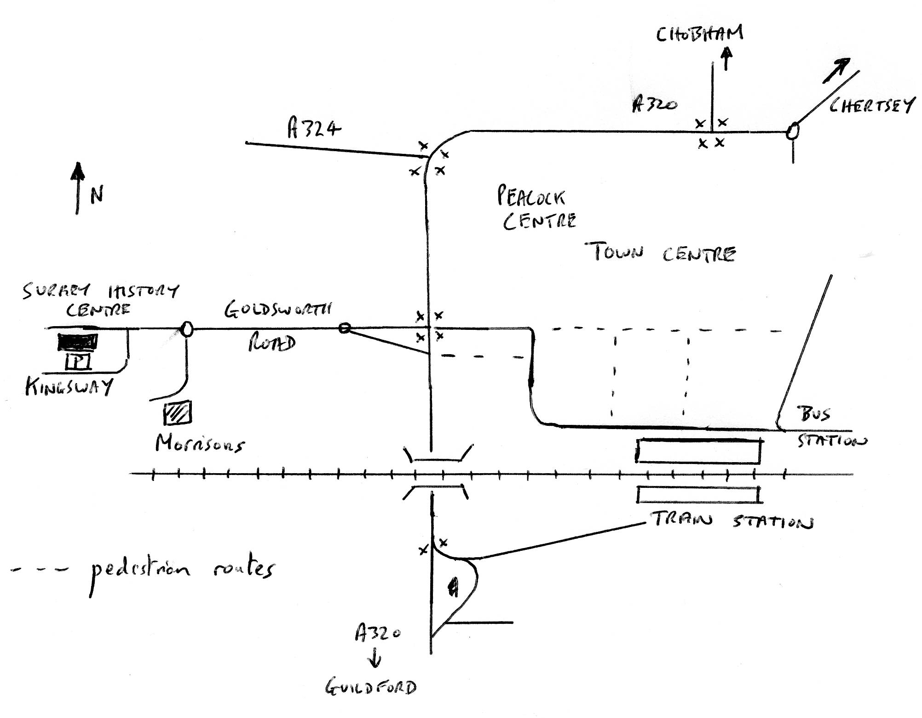

Surrey History Centre is located at 130 Goldsworth Road in Woking. It is approximately 2/3 of a mile from the Train and Bus Stations via the pedestrian route. Exit the train Station on the northern or town side i.e. from Platform 1.

PARKING

Parking is available free of charge at the Surrey History Centre. Access to the car park is from Kingsway at the rear of the building.

LUNCH

You are welcome to bring a packed lunch, tea and coffee will be available. The Surrey History Centre is about 15 minutes walk from Woking Town centre with its coffee shops, cafes and bakeries. There is a pub quite close by and Morrison’s Supermarket, which is about 5 minutes walk away, has a café and also sells sandwiches and salads etc.

