

SURREY ARCHAEOLOGICAL SOCIETY
A Company Limited by Guarantee. A Registered Charity No. 272098

Registered Office: CASTLE ARCH, GUILDFORD GU1 3SX Registered in England No. 1160052
Telephone/Fax: 01483 532454 Email: info@surreyarchaeology.org.uk

Villages Study Group
“Mining Maps & Digging for Evidence”

Surrey History Centre, 130 Goldsworth Road, Woking, GU21 6ND
Saturday 1st October 2011

10.00am Registration

10.30am Welcome & Introduction by David Taylor

10.35am ‘Mining Maps and Documents for Evidence’: Sally Jenkinson of Surrey History Centre and David Young of Surrey Archaeological Society will talk about the Surrey Tithe Records Project and how the output can be searched.

11.20am Collect tea/coffee and join the groups for a workshop session on deriving information by combining data from Tithe Maps and the Apportionment documents, led by Richard & Pamela Savage.

12.30pm Lunch Break – Tea & coffee available.

1.30pm ‘Digging for Evidence’: Richard Savage on test-pitting, featuring results from Old Woking in 2010 & 2011 and the implications for the development of the settlement.

2.00pm Updates on three current projects:
Bookham – Derek Renn
Ockham – Gillian Lachelin & Bob Primrose
Esher – Jo Richards

3.00pm Open discussion

3.30pm Close (building shuts at 4pm)

The cost of the day will be £6 per person payable on the day. Please pre-register with Jo Richards by completing and returning the slip below or by e-mailing her at jomrichards@yahoo.co.uk by Friday 23rd September 2011. For directions and parking see next page.

Villages Study Group - Workshop
1st October 2011 at Surrey History Centre, Goldsworth Road, Woking

I/We will be attending the above meeting (number attending …… )
Name …………………………………………………………………………………………………….
Tel No.…………………… Email/Address…………………………………………………………..
Replies to: Mrs J Richards, 4 Downside Court, Downs Lane, Leatherhead, KT22 8JW
01372 374034 email: jomrichards@yahoo.co.uk
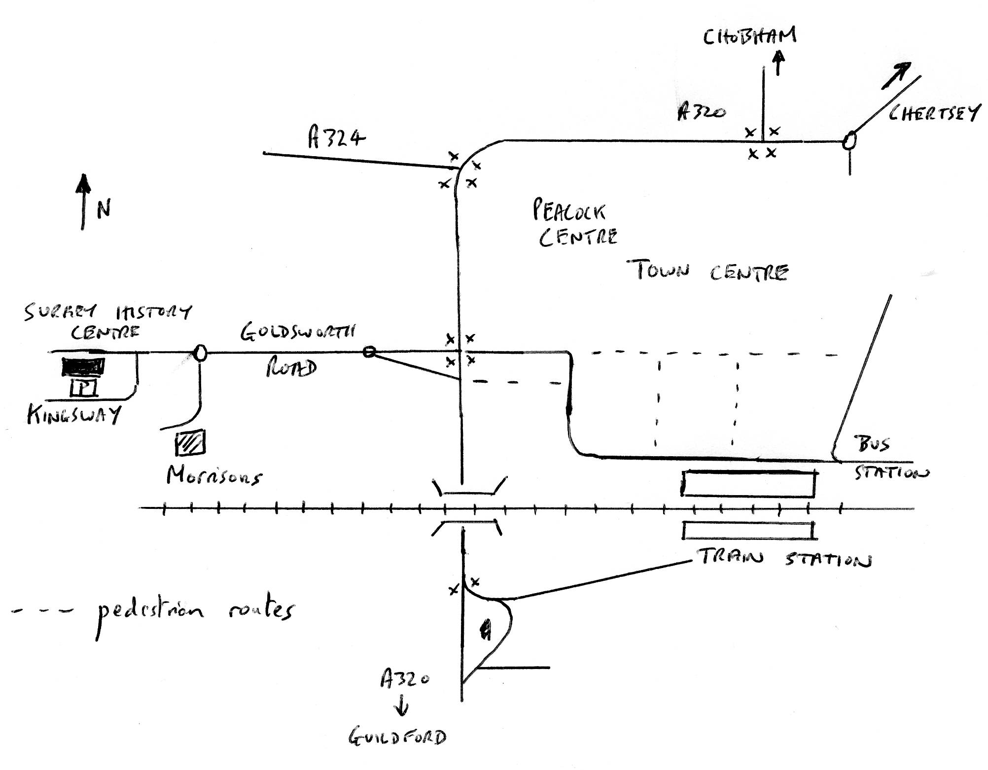

Surrey History Centre is located at 130 Goldsworth Road in Woking. It is approximately 2/3 of a mile from the Train and Bus Stations via the pedestrian route. Exit the train Station on the northern or town side i.e. from Platform 1.

PARKING

Parking is available free of charge at the Surrey History Centre. Access to the car park is from Kingsway at the rear of the building.

LUNCH

You are welcome to bring a packed lunch; tea and coffee will be available. The Surrey History Centre is about 15 minutes walk from Woking Town centre with its coffee shops, cafes and bakeries. There is a pub quite close by and Morrison’s Supermarket, which is about 5 minutes walk away, has a café and also sells sandwiches and salads etc.

